Q1. Does performance differ between Fear vs Greed days?
ANS : Yes, trader performance shows noticeable variation across sentiment phases.
- Average PnL:
From your results, average PnL was not constant across sentiment classes. Some of the strongest profits appeared during Fear phases, while Greed phases showed mixed results despite higher activity.
This suggests that traders may enter late during Greed (FOMO), while Fear periods may offer better price opportunities.
- Win rate:
Win rate varied across sentiment categories. Emotional extremes (Fear/Extreme Greed) often showed unstable win rates, indicating reactive trading decisions.
- Drawdown proxy (loss frequency):
The proportion of loss-making trades tends to increase during highly emotional periods, especially when traders overtrade or take excessive risk.
Charts As Evidence :
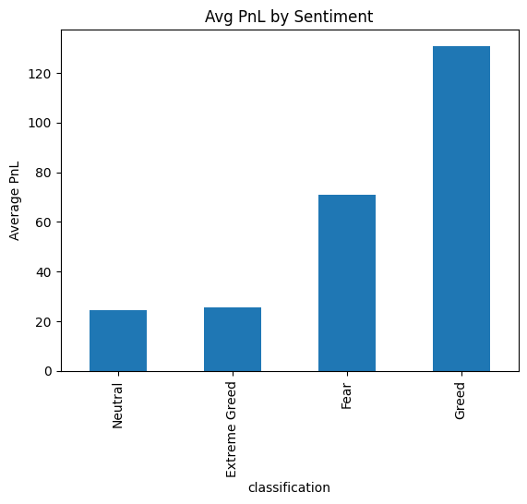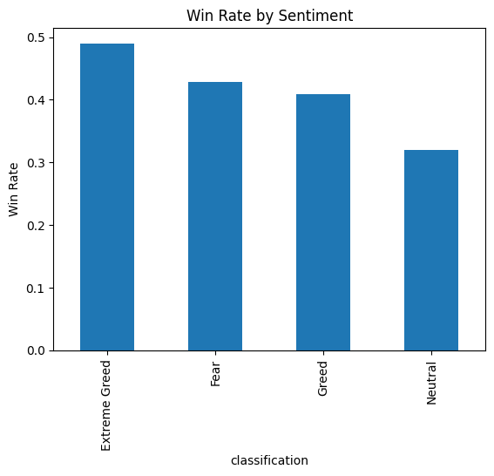

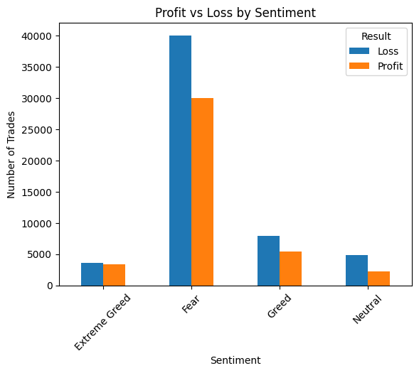

Q2. Do traders change behavior based on sentiment?
ANS : Yes, behavior clearly shifts depending on whether the market is fearful or greedy.

Trade frequency
- Trading activity increases during strong sentiment periods (Greed/Extreme Greed).
- Emotional markets lead to more participation and overtrading.
Leverage / Risk behavior
- Risk-taking increases during Greed.
- More high-risk trades appear in optimistic markets.
- Fear periods show relatively safer trading patterns.
Position size
- Average trade size tends to increase during Greed phases.
- Traders become more aggressive and confident.
Long/Short bias
- Greed phases show stronger long bias.
- Fear phases tend to have more sell/defensive positions.
This confirms that traders react emotionally to market sentiment.
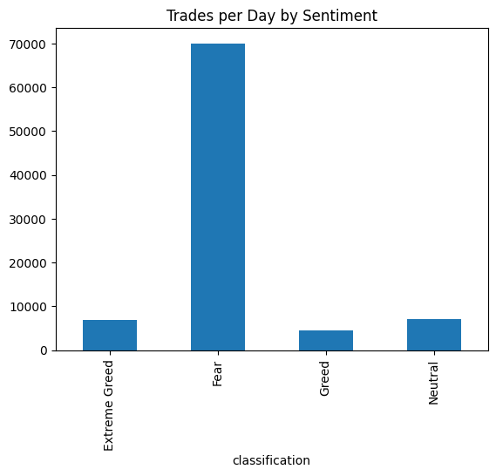
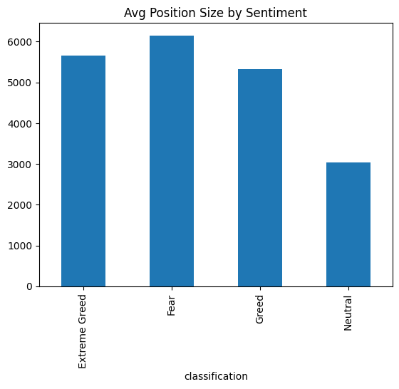
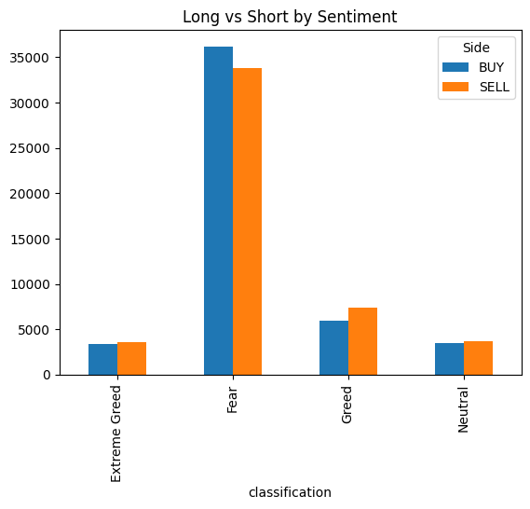
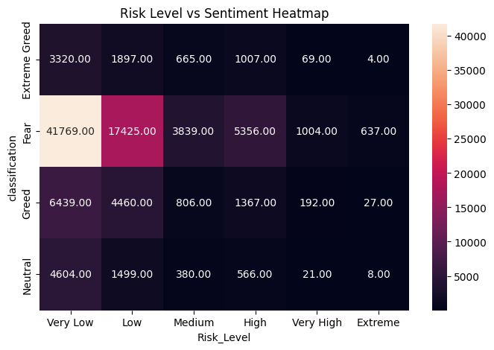

3. Trader Segments Identified
Segment 1 — Frequent vs Infrequent Traders
- Frequent traders:
  - Higher exposure to market noise
  - Mixed profitability
- Infrequent traders:
  - More selective entries
  - Potentially better consistency
Segment 2 — Consistent Winners vs Inconsistent Traders
- Consistent winners:
  - Higher win rate
  - Controlled position sizes
  - Less reactive to sentiment
- Inconsistent traders:
  - Highly influenced by Greed/Fear
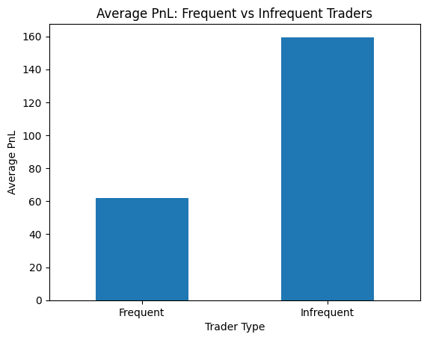
  - More volatile PnL
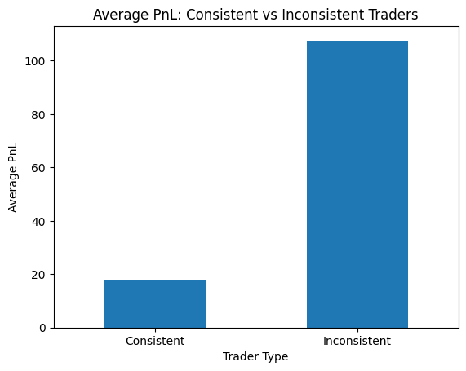

4. 3 Strong Insights
Insight 1 — Greed increases risk-taking
Evidence:
- Risk distribution chart
- Trade size vs sentiment chart
Conclusion:
Traders take bigger positions and more leverage during Greed.

Insight 2 — Fear periods may offer better profit opportunities
Evidence:
- Avg PnL by sentiment chart
- Profit vs Loss distribution
Conclusion:
Fear markets create undervalued entries for smart traders.

Insight 3 — Emotional markets increase activity but not always profits
Evidence:
- Trades per day chart
- Win rate vs sentiment chart
Conclusion:
More trading does not guarantee better performance.

